**DAILY ONLINE ACTIVITIES SUMMARY**

|  |  |  |  |  |  |
| --- | --- | --- | --- | --- | --- |
| **Date:** | **14-06-2020** | | **Name:** | **Shah Dhruvil Amit** | |
| **Sem & Sec** | **6th - B** | | **USN:** | **4AL17CS083** | |
| **Online Test Summary** | | | | | |
| **Subject** |  | | | | |
| **Max Score** |  | **Score** | |  | |
| **Certification Course Summary** | | | | | |
| **Course** |  | | | | |
| **Certificate Provider** |  | **Duration** | | |  |
| **Coding Challenges** | | | | | |
|  | | | | | |
| **Status: executed** | | | | | |
| **Uploaded the report in GitHub** | | **Yes** | | | |
| **If yes Repository name** | | <https://github.com/DhruvilShah99/Daily-Updates> | | | |
| **Uploaded the report in slack** | | **Yes** | | | |

Certification Course Details:

Report-

Coding Challenges Details:

The below GitHub link for details

<https://github.com/DhruvilShah99/Daily-Updates>

P-1-Java program to remove specific characters in the String

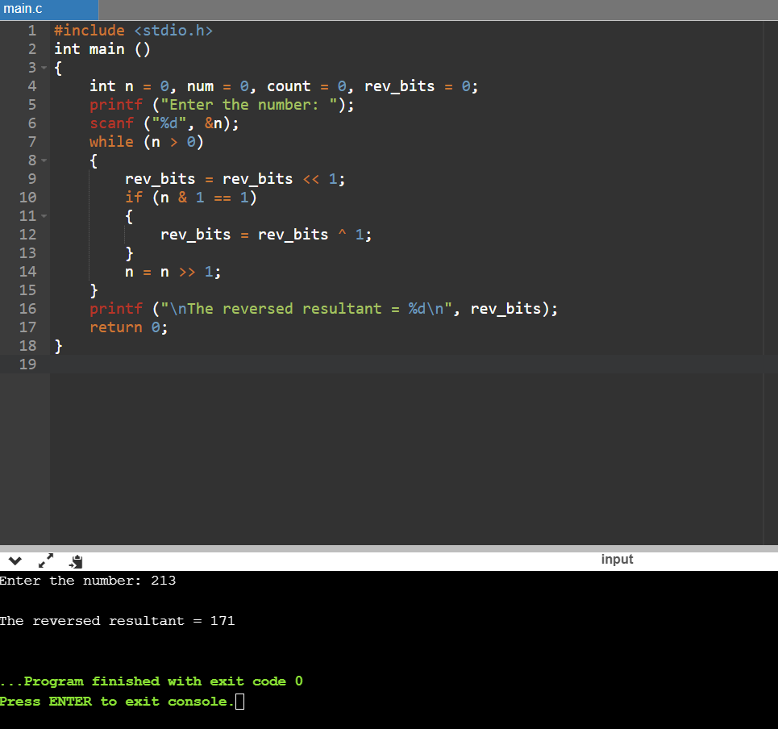

**P-2-**C Program to implement the Binary Description Have the function BinaryReversal(str) take the str parameter being passed, which will be a positive integer, take its binary representation, reverse that string of bits, and then finally return the new reversed string in decimal form. For example: if str is 47 then the binary version of this integer is 101111 but we pad it to be 00101111 (Total number of bits must be multiples of 4). Your program should reverse this binary string which then becomes: 11110100 and then finally return the decimal version of this string, which is 244. Examples Input: 213 Output: 171 Input: 4567 Output: 60296

